**Cupcake Express Requirement Specification**

**(Updated Version)**

Adele Francois, Jawan Higgins, Lance Toornman

June 18, 2016

## Section 1. Introduction

*1.1 Purpose of System*

The purpose of the client’s proposed system is to be a fully functional cupcake vending machine application that meets the client’s need of distributing cupcakes easily and generating revenue effectively.

*1.2 Scope of System*

The scope of the system consists of delivering real-time interactions with the user by allowing them to purchase custom cupcakes to their liking. The system is entirely touch screen-based and is designed to please users both visually and sensibly. The system provides freshly made cupcakes that are stocked each day and delivers an easy checkout process with assured security monitoring.

*1.3 Objectives & success criteria of the project*

* Allows the user to experience effective operation interaction and control the machine from a human perspective, whilst the machine simultaneously feeds back information to both the Administrator and aids the operator's decision-making process.
* User should be able to successfully order a specific product to their liking by having a choice of the following features: cake base flavoring, icing flavoring, and quantity of product.
* User confirms order and completes transaction process via both cash and credit processing options within the system.
* User receives both receipt for confirmed cupcake order and/or the change from their cash processing option.

*1.4 Overview*

Cupcake Express is recognized as the first bakery company to have a fully functional cupcake vending machine. The initial idea of creating a cupcake vending machine derives from recognizing that there was no company in the bakery market that had a dessert vending machine and it seemed like an opportune time to create one. Cupcake Express plans to become a leader in the area of dessert vending by setting the standard of efficiency, creativity, reliability and affordability.

## Section 2. Current System

Cupcake Express has not implemented any previous system applications that serve as a vending machine. There is no current system in existence.

### Section 3. Proposed System

*3.1 Overview*

Cupcake Express is an open 24-hour access vending machine that is equipped with delicious freshly made, hand crafted, daily stocked cupcakes. The Cupcake Express vending machine allows any person 13 years of age and older to purchase any selection of cupcakes. Cupcake Express provides easy in & out access by delivering fast processing for selecting and purchasing cupcakes in as little as 3 minutes. The machine accepts cash and credit cards, and ensures top level security in the customer’s best interest. Cupcake Express ultimately puts the interest of consumers above everything else and continues to think of new convenient ways to reach a bigger audience and deliver quality cupcake products

## Section 4. Functional Requirements

1. The system will provide select and purchase options for a variety of different cupcakes.
2. The system will allow users to navigate back to the previous selection stages.
3. The system will provide Administrative access to add, delete and update the type and quantity of cupcakes available.
4. The system will allow users to edit their selection of cupcake(s) if they decide to select a different cupcake/icing flavor.
5. The system will allow the user to only select up to the quantity amount that exists at the present time. (Ex. If there are only 5 cupcakes remaining, then up to 5 cupcakes can only be selected for that particular cupcake(s).)
6. The system will not allow the user to proceed to checkout if a cupcake is not selected.
7. The system will notify the user when cupcakes are out of stock.
8. The system will calculate the total price of the cupcake by factoring in the sales tax and the quantity of cupcakes.
9. The system will return change to the user when cupcakes are purchased with cash, if applicable.
10. The system will print a receipt for the purchase including the total price and quantity of the cupcake(s).

## Section 5. Non-Functional Requirements

1. *Usability*

* Application should be accessible on all versions of vendor hardware.
* The system only supports one purchaser at a time, but can support many Administrative users.
* The system should provide easy navigation with clear navigable naming conventions.

1. *Reliability*

* The system should support hundreds of users consecutively with continuous functionality without any freezes or delays.
* The system should withstand weather conditions such as rain, hail, snow, etc. by using thick layers of metal for the body and shatter proof glass for the screen.
* The system will always store a large quantity of cupcakes and almost never out of stock to ensure customers that our machines are very reliable.
* In the event of system failure, the system can only afford to fail a maximum of two times in a year.
* Shutdown occurrences or freeze ups should not occur for more than ten minutes.

1. *Performance*

* Application should be able to transition from one stage to another in no more than ten seconds.
* The system should be able to select and purchase cupcakes within a maximum time of 3 minutes for the average user.
* The system should process the input of cash and credit cards in less than 5 seconds.
* The system will transition to each screen in less than 10 seconds.

1. *Supportability*

* The system supports storage space for up to 18 different cupcake combinations.

1. *Implementation*

* The system will implement a database to store a variety of cupcakes, keeping track of all transactions, which will add and delete cupcakes in real time.
* The system will implement Administrative access to the back-end of the system for adding, deleting and updating the type of cupcakes.

1. *Interface*

* The system should have an option for the user to print out their receipt from their purchase.

1. *Packaging*

* The system should have a maximum of 10 cupcakes per selection.
* The system should deliver a package sealed cupcake in perfect condition as it was freshly made.
* The system should provide a shelf life for the cupcakes of 15 days.

1. *Legal*

* Essential to know the specific area laws and jurisdictions in each vending machine location.
* Acquiring appropriate business licenses, taxes, health inspection accreditation, etc for each location.
* No person below the age of 13 can purchase a cupcake without an adult above the age of 18 present.

## Section 6. Use-Case Diagrams & Descriptions

1. *Scenarios*

**Scenario Name:** PayWithCash

**Participating Actor Instances:** bob:User

**Flow of Events:**

1. Bob touches the screen to start the application.
2. Bob selects the icing.
3. Bob selects the cupcake
4. Bob selects quantity
5. Bob proceeds to payment
6. Bob selects to pay in cash
7. Bob receives change as necessary.

**Scenario Name:** PayWithCredit

**Participating Actor Instances:** bob:User

**Flow of Events:**

1. Bob touches the screen to start the application.
2. Bob selects the icing.
3. Bob selects the cupcake
4. Bob selects quantity
5. Bob proceeds to payment
6. Bob selects to pay in credit

**Scenario Name:** OutOfOrder

**Participating Actor Instances:** bob:User

**Flow of Events:**

1. Bob touches the screen to start the application.
2. Bob selects the icing.
3. Bob selects the cupcake
4. Bob selects quantity
5. Bob receives out of order notification
6. Bob must reselect or terminate process

**Scenario Name:** AdministratorRestock

**Participating Actor Instances:** jane:Administrator

**Flow of Events:**

1. Jane logs in
2. Jane is brought to the update/change system screen
3. Jane selects the pull down menu of the icing she would like to restock
4. Jane selects strawberry as the icing to restock, and adjusts the quantity to reflect the current stock in the machine
5. Jane taps the confirm button to confirm her choice
6. Jane automatically gets logged out after confirmation
7. Jane gets returned to the home screen

**Scenario Name:** AdministratorLineChange

**Participating Actor Instances:** jane:Administrator

**Flow of Events:**

1. Jane logs in
2. Jane is brought to the update/change system screen
3. Jane presses the button to add a cupcake and selects the type to add.
4. Jane presses the button to add an icing and selects the type to add.
5. Jane chooses to remove the chocolate icing selection from the page by selecting the Remove option from the dropdown menu.
6. Jane taps the confirm button to confirm her choice
7. Jane automatically gets logged out after the confirmation
8. Jane gets returned to the home screen
9. *Use Case Models*

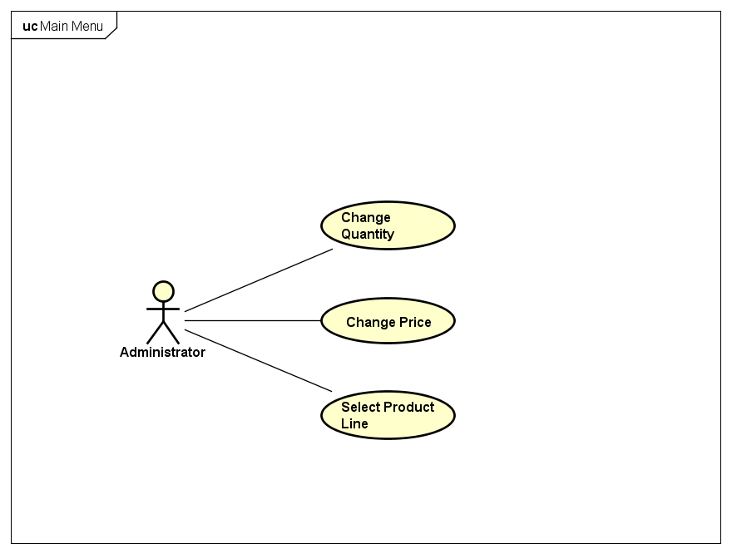

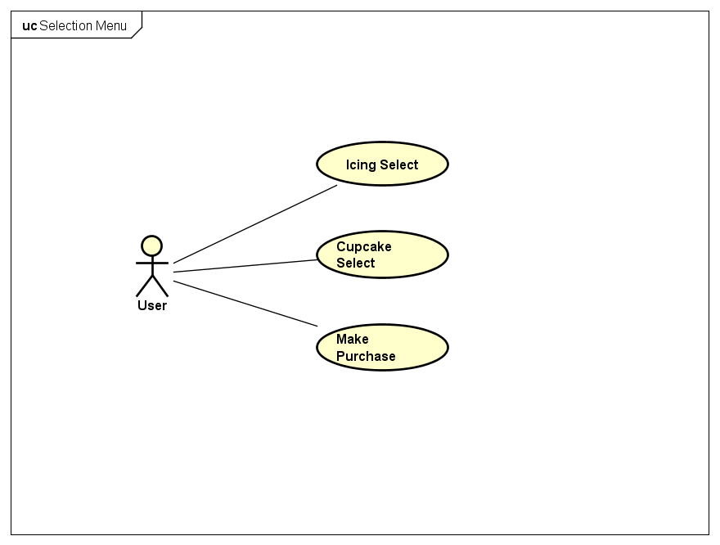

1. *Descriptions*

**Use Case Name:** SelectionMenu

**Participating Actors:** Initiated by Customers/User

**Flow of Events**:

1. Customer selects the Customer button on the main menu.
2. Customer proceeds to the selection.
3. Customer makes selection of icing, clicks next
4. Customer makes selection of cupcake base, clicks next
5. Customer makes selection of quantity desired
6. Customer confirms final decisions
7. Customer proceeds to payment screen
8. Customer selects to pay with either cash or credit
9. Customer receives change as appropriate
10. Customer receives receipt

**Entry Condition:** The user engages with the vending machine as a customer.

**Exit Condition:** The user complete or cancels transaction.

**Quality Requirements:** To handle the payment transaction, the vending machine must be equipped with the proper hardware.

**Use Case Name:** MainMenu

**Participating Actors:** Administrator

**Flow of Events:**

1. Administrator logs into the main menu to allow for administrative actions to occur.
2. Administrator may change the quantity of cupcakes to reflect the current stock.

**Entry Condition:** Administrator must engage with the machine with authorized login credentials.

**Exit Condition:** Administrator terminates session after making desired changes.

**Use Case Name:** MainMenu

**Participating Actors:** Administrator

**Flow of Events:**

1. Administrator logs into the main menu to allow for administrative actions to occur.
2. Administrator may change the price of cupcakes to reflect market trends/desires.

**Entry Condition:** Administrator must engage with the machine with authorized login credentials.

**Exit Condition:** Administrator terminates session after making desired changes.

**Use Case Name:** MainMenu

**Participating Actors:** Administrator

**Flow of Events:**

1. Administrator logs into the main menu to allow for administrative actions to occur.
2. Administrator may add items to the screen via onscreen buttons.

**Entry Condition:** Administrator must engage with the machine with authorized login credentials.

**Exit Condition:** Administrator terminates session after making desired changes.

**Use Case Name:** MainMenu

**Participating Actors:** Administrator

**Flow of Events:**

1. Administrator logs into the main menu to allow for administrative actions to occur.
2. Administrator may remove items from the screen via the drop down menu

**Entry Condition:** Administrator must engage with the machine with authorized login credentials.

**Exit Condition:** Administrator terminates session after making desired changes.

## 

## 

## 

## Section 7. Glossary

Administrator: person(s) who are responsible for monitoring: security configuration, allocation of user names and passwords, disk space and resource use, and making changes to an overall system.

Cupcake: a small cake, the size of an individual portion, baked in a cup-shaped mold.

Customer: a person who purchases goods or services from another buyer or patron.